**INTRODUCTION**

The main aim of the this project is to get the best content for the people who loves the reading .In this digital world everyone want all the things from the internet . As we know world is going digitalize and people get their all the things online . So we are trying to make the website which contain the stories ,poems and other things. This website content is interesting for all the age groups from childs to oldies.

**ABSTRACT**

The main motto of creating this project is ' Why to look at different websites for the different

book's poems and quotes'. In this project, we are going to create a dynamic website name

"READERSBAY". This website will be fruitful for both readers and the writers, who want to

showcase their talents to others. With the help of this website the readers who love to read both

long novels and short stories, interesting quotes, and poems will be able to get access to it and

that also in one website. This website will help the readers to get these things on their fingertips

anytime and anywhere they want. The writers who want to exhibit their talent of creative thinking

by sharing the stories, express their emotions and feelings through the poems and, inspire and

motivate people with their thoughts and quotes are always welcomed to portray what they have.

This website will be easy to use and fruitful for both readers and writers

**PROPOSED SYSTEM**

**SOFTWARE REQUIREMENT:** Xamp/Wamp, Internet Browser, Windows, Sublime Text 3, HTML5 , CSS 3.0 ,AJAX, PHP.

**MODULES**

Page 1: - ReadersBay Login page Or Register Page.

Page 2: - Option Page, whether to choose Quotes Page or Book Page or Poetry Page or Short Stories.

Page 3: - Quotes Categories/page.

Page 5: - Short Stories Categories/page.

Page 6: - Book Page Categories/page.

Page 7: - Poetry Page Categories/page.

Page 8: - LogOut Page.

**RESPONSIVE WEB DESIGN FRAMEWORK**

**What is a framework? With Example**

A framework is a standardized set of concepts, practices and criteria for dealing with a common type of problem, which can be used as a reference to help us approach and resolve new problems of a similar nature. In the world of web design, to give a more straightforward deﬁnition, a framework is deﬁned as a package made up of a structure of ﬁles and folders of standardized code (HTML, CSS, JS documents etc.) which can be used to support the development of websites, as a basis to start building a site. Most websites share a very similar (not to say identical) structure. The aim of frameworks is to provide a common structure so that developers dont have to redo it from scratch and can reuse the code provided. In this way, frameworks allow us to cut out much of the work and save a lot of time.

Bootstrap: Bootstrap is a free front-end framework for faster and easier web development. Bootstrap includes HTML and CSS based design templates for typography, forms, buttons, tables, navigation, modals, image carousels and many other, as well as optional JavaScript plugins.

Material design: Material Design is a visual language that synthesizes the classic principles of good design with the innovation of technology and science.

**CSS**

* **CSS** stands for **C**ascading **S**tyle **S**heets
* CSS describes **how HTML elements are to be displayed on screen, paper, or in other media**
* CSS **saves a lot of work**. It can control the layout of multiple web pages all at once
* External stylesheets are stored in **CSS files**

**TYPES OF CSS**

CSS comes in three types:

1.In a separate ﬁle (external)

2.At the top of a web page document (internal)

3.Right next to the text it decorates (inline)

External style sheets are separate ﬁles full of CSS instructions (with the ﬁle extension .css). When any web page includes an external stylesheet, its look and feel will be controlled by this CSS ﬁle (unless you decide to override a style using one of these next two types). This is how you change a whole website at once. And that’s perfect if you want to keep up with the latest fashion in web pages without rewriting every page! Internal styles are placed at the top of each web page document, before any of the content is listed. This is the next best thing to external, because they’re easy to ﬁnd, yet allow you to ’override’ an external style sheet – for that special page that wants to be a nonconformist! Inline styles are placed right where you need them, next to the text or graphic you wish to decorate. You can insert inline styles anywhere in the middle of your HTML code, giving you real freedom to specify each web page element. On the other hand, this can make maintaining web pages

**CSS CODE**

**RegisterPage.html**

<style>

body {

font-family: Arial, Helvetica, sans-serif;

background-image: url("https://images.wallpaperscraft.com/image/book_glasses_tea_chair_cup_garden_80317_4272x3123.jpg");

background-repeat:no-repeat;

background-size: cover;

}

* {

box-sizing: border-box;

}

.container {

padding: 16px;

background-color: white;

}

input[type=text], input[type=password], input[type=email]{

width: 50%;

padding: 15px;

margin: 5px 0 22px 0;

display: inline-block;

border: none;

background: #f1f1f1;

}

input[type=text]:focus, input[type=password]:focus {

background-color: #ddd;

outline: none;

}

/* Overwrite default styles of hr */

hr {

border: 1px solid #f1f1f1;

margin-bottom: 25px;

}

/* Set a style for the submit button */

.registerbtn {

background-color: red;

color: white;

padding: 16px;

margin: 5px 0 22px 0;

border: none;

cursor: pointer;

width: 25%;

opacity: 0.9;

}

.registerbtn:hover {

opacity: 1.5;

}

/* Add a blue text color to links */

a {

color: dodgerblue;

}

/* Set a grey background color and center the text of the "sign in" section */

.signin {

background-color: #f1f1f1;

text-align: center;

}

</style>

**Login.php**

<style>

body {

font-family: Arial, Helvetica, sans-serif;

background-image: url("https://images.wallpaperscraft.com/image/book_coffee_bed_shadow_117507_1280x720.jpg");

background-repeat:no-repeat;

background-size: cover;

}

* {

box-sizing: border-box;

}

.container {

padding: 16px;

background-color: white;

}

input[type=text], input[type=password], input[type=email]{

width: 50%;

padding: 15px;

margin: 5px 0 22px 0;

display: inline-block;

border: none;

background: #f1f1f1;

}

input[type=text]:focus, input[type=password]:focus {

background-color: #ddd;

outline: none;

}

/* Overwrite default styles of hr */

hr {

border: 1px solid #f1f1f1;

margin-bottom: 25px;

}

/* Set a style for the submit button */

.registerbtn {

background-color: coral;

color: white;

padding: 16px;

margin: 5px 0 22px 0;

border: none;

cursor: pointer;

width: 25%;

opacity: 0.9;

}

.registerbtn:hover {

opacity: 1.5;

}

/* Add a blue text color to links */

a {

color: dodgerblue;

}

/* Set a grey background color and center the text of the "sign in" section */

.signin {

background-color: #f1f1f1;

text-align: center;

}</style>

**OptionPage.html**

<style>

* {

box-sizing: border-box;

}

.button1 {

background-color:red;

border: 3px;

color: white;

padding: 8px;

text-align: center;

text-decoration: none;

display: inline-block;

margin: 2px 4px;

cursor: pointer;

border-radius: 4px;

border: 2px solid grey;

}

.button1:hover {

background-color: black;

color: white;

}

.button2 {

background-color:blue;

border: 3px;

color: white;

padding: 8px;

text-align: center;

text-decoration: none;

display: inline-block;

margin: 2px 4px;

cursor: pointer;

border-radius: 4px;

border: 2px solid grey;

}

.button2:hover {

background-color: black;

color: white;

}

.button3 {

background-color:green;

border: 3px;

color: white;

padding: 8px;

text-align: center;

text-decoration: none;

display: inline-block;

margin: 2px 4px;

cursor: pointer;

border-radius: 4px;

border: 2px solid grey;

}

.button3:hover {

background-color: black;

color: white;

}

.button4{

background-color:purple;

border: 3px;

color: white;

padding: 8px;

text-align: center;

text-decoration: none;

display: inline-block;

margin: 2px 4px;

cursor: pointer;

border-radius: 4px;

border: 2px solid grey;

}

.button4:hover {

background-color: black;

color: white;

}

.menu {

float:left;

width:20%;

text-align:center;

}

.menu a {

padding:8px;

margin-top:7px;

display:block;

width:100%;

color:black;

}

.main {

float:left;

width:60%;

padding:0 20px;

}

.right {

float:left;

width:20%;

padding:15px;

margin-top:7px;

text-align:center;

}

@media only screen and (max-width:620px) {

/* For mobile phones: */

.menu, .main, .right {

width:100%;

}

}

body {

background-image:url("https://images.wallpaperscraft.com/image/book_paper_leaves_hearts_25729_1920x1200.jpg");

background-repeat: no-repeat;

background-size: cover;

}

</style>

**SYSTEM ARCHITECTURE**

**PHP**

PHP is a server scripting language, and a powerful tool for making dynamic and interactive Web pages.

To connect to MySQL DataBase using PHP:

There are several methods for connecting to a MySQL database using PHP: 1.)MySQL Improved (mysqli) extension

2.)PDO (PHP Data Objects)

3.)Legacy MySQL (mysql) function

For our project we have used First one mysqli extension to connect Database.

**Register.php**

<?php

$FullName = $_POST['fname'];

$Email = $_POST['email'];

$dbconnect=mysqli_connect("localhost","root","","pg1");

if(mysqli_connect_errno($dbconnect)){

echo "failed to connect";

}

else {

$INSERT = "INSERT into page1 (fname,email) values(?,?)";

$stmt = $dbconnect->prepare($INSERT);

$r= $stmt->num_rows;

if ($r==0){

$stmt->bind_param("ss",$FullName,$Email);

$stmt->execute();

$stmt->store_result();

header("location: Login.php");

}

else

{echo "Record is same";}

}

?>

**Login.php**

<?php

$conn=mysqli_connect("localhost","root","","pg1");

extract($_POST);

$FullName = $_POST['fname'];

$Email = $_POST['email'];

if(isset($submit))

{

$rs=mysqli_query($conn,"select * from page1 where fname='$FullName' and Email='$email'");

if(mysqli_num_rows($rs)<1)

{

$found="N";

}

else

{

$_SESSION["login"]=$FullName;

}

}

if (isset($_SESSION["login"]))

{

session_start();

$_SESSION["name"]=$FullName;

header("Location: second page.html");}

else

{echo "Invalid User";

header("Location: loginerror.php");

}

?>

**LogOut.php**

<?php

session_start();

unset($_SESSION["login"]);

session_destroy();

header("Location: login.php");

exit; ?>

**Poems.php**

A<!DOCTYPE html>

<html>

<head>

<meta name="viewport" content="width=device-width, initial-scale=1.0">

<style>

* {

box-sizing: border-box;

}

body{

ont-family: Arial, Helvetica, sans-serif;

background-image: url("book.jpg");

background-repeat:no-repeat;

background-size: cover;

}

.menu {

float:left;

width:20%;

text-align:center;

}

.menu a {

padding:8px;

margin-top:7px;

display:block;

width:100%;

color:black;

}

.main {

float:center;

width:60%;

padding:0 20px;

}

.right {

float:right;

width:20%;

padding:15px;

margin-top:7px;

text-align:center;

}

@media only screen and (max-width:620px) {

/* For mobile phones: */

.menu, .main, .right {

width:100%;

}

}

.dropbtn {

background-color: red;

color: white;

padding: 16px;

font-size: 16px;

border: none;

cursor: pointer;

margin-left:50px;

}

.dropbtn:hover, .dropbtn:focus {

background-color:red;

margin-left:50px;

}

.dropdown {

position: relative;

display: inline-block;

}

.dropdown-content {

display: none;

position: absolute;

background-color:white;

min-width: 160px;

overflow: auto;

box-shadow: 0px 8px 16px 0px rgba(0,0,0,0.2);

z-index: 1;

}

.dropdown-content a {

color: black;

padding: 12px 16px;

text-decoration: none;

display: block;

}

.dropdown a:hover {background-color:red;

padding:8px;

margin-top:7px;

display:block;

width:100%;

color:black;}

.show {display: block;}

</style>

</head>

<body style="font-family:Verdana;color:black;">

<div style=padding:5px;text-align:center;>

<h1 style="font-size:50px;"><font color="red">POEMS</font></h1>

</div>

<div class="menu">

<div class="dropdown">

<button onclick="myFunction()" class="dropbtn" margin-left="7px" >CATEGORY</button>

<div id="myDropdown" class="dropdown-content">

<form action="POEMS.php" method="get">

<a href="sad.php">sad </a>

<a href="love.php">love and friendship</a>

<a href="dark.php">dark and death</a>

</form>

</div>

</div>

</div>

<div class="main">

<?php

$a= mysqli_connect("localhost","root","","pg1");

$res= mysqli_query($a,"select * from poems");

while($row=mysqli_fetch_array($res))

{

?> <p text align="center" style="font-size: 20px">Shall I compare thee to a summer’s day?

Thou art more lovely and more temperate:

Rough winds do shake the darling buds of May,

And summer’s lease hath all too short a date:

Sometime too hot the eye of heaven shines,

And often is his gold complexion dimm’d;

And every fair from fair sometime declines,

By chance, or nature’s changing course, untrimm’d;

But thy eternal summer shall not fade

Nor lose possession of that fair thou ow’st;

Nor shall Death brag thou wander’st in his shade,

When in eternal lines to time thou grow’st;

So long as men can breathe or eyes can see,

So long lives this, and this gives life to thee.

</p>

<p align="right" style="font-size: 20px"><i>~ William Shakespeare</i></p>

<p text align="justify" style="font-size: 20px"><?php echo $row["SrNo"]; ?><br /></p>

<pre text align="center" style="font-size: 20px"><?php echo $row["data"]; ?><br /></pre>

<p align="right" style="font-size: 20px"><i>~<?php echo $row["Author"]; ?></i><br /></p>

<?php

}

?>

</div>

<div class="right">

<form action ="store.php" method="post">

Author name:<input type="text" name="name"><br/><br/>

Share your thoughts:<textarea id="words" rows="10" cols="20"></textarea><br/><br/>

<input type="submit" value="submit">

</form>

</div>

<div>

</div>

<script>

/* When the user clicks on the button,

toggle between hiding and showing the dropdown content */

function myFunction() {

document.getElementById("myDropdown").classList.toggle("show");

}

// Close the dropdown if the user clicks outside of it

window.onclick = function(event) {

if (!event.target.matches('.dropbtn')) {

var dropdowns = document.getElementsByClassName("dropdown-content");

var i;

for (i = 0; i < dropdowns.length; i++) {

var openDropdown = dropdowns[i];

if (openDropdown.classList.contains('show')) {

openDropdown.classList.remove('show');

}

}

}

}

</script>

<header>

<div class="container">

<h1 class="logo"></h1>

<nav>

<ul>

<li><a href="#">Home</a></li>

<li><a href="#">Cart</a></li>

<li><a href="logout.php">logout</a></li>

</ul>

</nav>

</div>

</header>

</body>

</html>

**ShortStories.php**

<!DOCTYPE html>

<html>

<head>

<meta name="viewport" content="width=device-width, initial-scale=1.0">

<style>

* {

box-sizing: border-box;

}

.menu {

float:left;

width:20%;

text-align:center;

}

.menu a {

padding:8px;

margin-top:7px;

display:block;

width:100%;

color:black;

}

.main {

float:center;

width:60%;

padding:0 20px;

}

.right {

float:right;

width:20%;

padding:15px;

margin-top:7px;

text-align:center;

}

@media only screen and (max-width:620px) {

/* For mobile phones: */

.menu, .main, .right {

width:100%;

}

}

body {

background-image:url("story.jpg");

background-repeat: no-repeat;

background-size: cover;

}

.dropbtn {

background-color: green;

color: white;

padding: 16px;

font-size: 16px;

border: none;

cursor: pointer;

margin-left:50px;

}

.dropbtn:hover, .dropbtn:focus {

background-color: brown;

margin-left:50px;

}

.dropdown {

position: relative;

display: inline-block;

}

.dropdown-content {

display: none;

position: absolute;

background-color:white;

min-width: 160px;

overflow: auto;

box-shadow: 0px 8px 16px 0px rgba(0,0,0,0.2);

z-index: 1;

}

.dropdown-content a {

color: black;

padding: 12px 16px;

text-decoration: none;

display: block;

}

.dropdown a:hover {background-color:brown;

padding:8px;

margin-top:7px;

display:block;

width:100%;

color:black;}

.show {display: block;}

</style>

</head>

<body style="font-family:Verdana;color:black;">

<header>

<div class="container">

<h1 class="logo"></h1><nav>

<ul>

<li><a href="second page.html">Home</a></li>

<li><a href="logout.php">logout</a></li>

</ul>

</nav>

</div>

</header>

<div style=padding:5px;text-align:center;>

<h1 style="font-size:50px;"><font color="red">SHORT STORY</font></h1>

</div>

<div class="menu">

<div class="dropdown">

<button onclick="myFunction()" class="dropbtn" margin-left="7px" >CATEGORY</button>

<div id="myDropdown" class="dropdown-content">

<form action="POEMS.php" method="get">

<a href="happy.php">Happy</a>

<a href="lovestory.php">love </a>

<a href="horror.php">Horror</a>

</form>

</div>

</div>

</div>

<div class="main">

<?php

$a= mysqli_connect("localhost","root","","pg1");

$res= mysqli_query($a,"select * from poems");

while($row=mysqli_fetch_array($res))

{

?>

<p text align="justify" style="font-size: 20px"><?php echo $row["SrNo"]; ?><br /></p>

<pre text align="center" style="font-size: 20px"><?php echo $row["data"]; ?><br /></pre>

<p align="right" style="font-size: 20px"><i>~<?php echo $row["Author"]; ?></i><br /></p>

<?php

}?>

</div><div class="right"> </div>

<script>

/* When the user clicks on the button,

toggle between hiding and showing the dropdown content */

function myFunction() {

document.getElementById("myDropdown").classList.toggle("show");

}

// Close the dropdown if the user clicks outside of it

window.onclick = function(event) {

if (!event.target.matches('.dropbtn')) {

var dropdowns = document.getElementsByClassName("dropdown-content");

var i;

for (i = 0; i < dropdowns.length; i++) {

var openDropdown = dropdowns[i];

if (openDropdown.classList.contains('show')) {

openDropdown.classList.remove('show');

}

}

}

}

</script></body>

</html>

**Books.Php**

<!DOCTYPE html>

<html>

<head>

<meta name="viewport" content="width=device-width, initial-scale=1.0">

<style>

* {

box-sizing: border-box;

}

.menu {

float:left;

width:20%;

text-align:center;

}

.menu a {

padding:8px;

margin-top:7px;

display:block;

width:100%;

color:black;

}

.main {

float:center;

width:60%;

padding:0 20px;

}

.right {

float:right;

width:20%;

padding:15px;

margin-top:7px;

text-align:center;

}

@media only screen and (max-width:620px) {

/* For mobile phones: */

.menu, .main, .right {

width:100%;

}

}

body {

background-image:url("https://images.wallpaperscraft.com/image/book_paper_leaves_hearts_25729_1920x1200.jpg");

background-image:url("sp1.jpg");

background-repeat: no-repeat;

background-size: cover;

}

.dropbtn {

background-color: green;

color: white;

padding: 16px;

font-size: 16px;

border: none;

cursor: pointer;

margin-left:50px;

}

.dropbtn:hover, .dropbtn:focus {

background-color: brown;

margin-left:50px;

}

.dropdown {

position: relative;

display: inline-block;

}

.dropdown-content {

display: none;

position: absolute;

background-color:white;

min-width: 160px;

overflow: auto;

box-shadow: 0px 8px 16px 0px rgba(0,0,0,0.2);

z-index: 1;

}

.dropdown-content a {

color: black;

padding: 12px 16px;

text-decoration: none;

display: block;

}

.dropdown a:hover {background-color:brown;

padding:8px;

margin-top:7px;

display:block;

width:100%;

color:black;}

.show {display: block;}

</style>

</head>

<body style="font-family:Verdana;color:black;">

<header>

<div class="container">

<h1 class="logo"></h1>

<nav>

<ul>

<li><a href="secondpage.html">Home</a></li>

<li><a href="#">Cart</a></li>

<li><a href="logout.php">logout</a></li>

</ul>

</nav>

</div>

</header>

<div style=padding:5px;text-align:center;>

<h1 style="font-size:50px;"><font color="red">BOOKS</font></h1>

</div>

<div class="menu">

<div class="dropdown">

<button onclick="myFunction()" class="dropbtn" margin-left="7px" >CATEGORY</button>

<div id="myDropdown" class="dropdown-content">

<form action="POEMS.php" method="get">

<a href="sadd.php">sad</a>

<a href="lovee.php">love </a>

<a href="horrorr.php">Horror</a>

</form>

</div>

</div>

</div>

<div class="main">

<?php

$a= mysqli_connect("localhost","root","","pg1");

$res= mysqli_query($a,"select * from poems");

while($row=mysqli_fetch_array($res))

{

?>

<p text align="justify" style="font-size: 20px"><?php echo $row["SrNo"]; ?><br /></p>

<pre text align="center" style="font-size: 20px"><?php echo $row["data"]; ?><br /></pre>

<p align="right" style="font-size: 20px"><i>~<?php echo $row["Author"]; ?></i><br /></p>

<?php

}

?>

</div>

<div class="right">

<form action ="store.php" method="post">

Author name:<input type="text" name="name"><br/><br/>

Share your thoughts:<textarea id="words" rows="10" cols="20"></textarea><br/><br/>

<input type="submit" value="submit">

</form>

</div>

<div>

</div>

<script>

/* When the user clicks on the button,

toggle between hiding and showing the dropdown content */

function myFunction() {

document.getElementById("myDropdown").classList.toggle("show");

}

// Close the dropdown if the user clicks outside of it

window.onclick = function(event) {

if (!event.target.matches('.dropbtn')) {

var dropdowns = document.getElementsByClassName("dropdown-content");

var i;

for (i = 0; i < dropdowns.length; i++) {

var openDropdown = dropdowns[i];

if (openDropdown.classList.contains('show')) {

openDropdown.classList.remove('show');

}

}

}

}

</script>

</body>

</html>

**Quotes.php**

<!DOCTYPE html>

<html>

<head>

<meta name="viewport" content="width=device-width, initial-scale=1.0">

<style>

* {

box-sizing: border-box;

}

.menu {

float:left;

width:20%;

text-align:center;

}

.menu a {

padding:8px;

margin-top:7px;

display:block;

width:100%;

color:black;

}

.main {

float:center;

width:60%;

padding:0 20px;

}

.right {

float:right;

width:20%;

padding:15px;

margin-top:7px;

text-align:center;

}

@media only screen and (max-width:620px) {

/* For mobile phones: */

.menu, .main, .right {

width:100%;

}

}

body {

background-image:url("https://images.wallpaperscraft.com/image/book_paper_leaves_hearts_25729_1920x1200.jpg");

background-image:url("quotes.jpg");

background-repeat: no-repeat;

background-size: cover;

}

.dropbtn {

background-color: green;

color: white;

padding: 16px;

font-size: 16px;

border: none;

cursor: pointer;

margin-left:50px;

}

.dropbtn:hover, .dropbtn:focus {

background-color: brown;

margin-left:50px;

}

.dropdown {

position: relative;

display: inline-block;

}

.dropdown-content {

display: none;

position: absolute;

background-color:white;

min-width: 160px;

overflow: auto;

box-shadow: 0px 8px 16px 0px rgba(0,0,0,0.2);

z-index: 1;

}

.dropdown-content a {

color: black;

padding: 12px 16px;

text-decoration: none;

display: block;

}

.dropdown a:hover {background-color:brown;

padding:8px;

margin-top:7px;

display:block;

width:100%;

color:black;}

.show {display: block;}

</style>

</head>

<body style="font-family:Verdana;color:black;">

<header>

<div class="container">

<h1 class="logo"></h1>

<nav>

<ul>

<li><a href="second page.html">Home</a></li>

<li><a href="logout.php">logout</a></li>

</ul>

</nav>

</div>

</header>

<div style=padding:5px;text-align:center;>

<h1 style="font-size:50px;"><font color="red">QUOTES</font></h1>

</div>

<div class="menu">

<div class="dropdown">

<button onclick="myFunction()" class="dropbtn" margin-left="7px" >CATEGORY</button>

<div id="myDropdown" class="dropdown-content">

<form action="POEMS.php" method="get">

<a href="kpop.php">kpop and kdrama</a>

<a href="lovenf.php">love and friendship</a>

<a href="death.php">dark and death</a>

</form>

</div>

</div>

</div>

<div class="main">

<pre text align="center" style="font-size: 20px">An Investment in Knowledge pays the best Interest.<br /></pre>

<p align="right" style="font-size: 20px"><i>~Benjamin Franklin</i><br /></p>

</div>

<script>

/* When the user clicks on the button,

toggle between hiding and showing the dropdown content */

function myFunction() {

document.getElementById("myDropdown").classList.toggle("show");

}

// Close the dropdown if the user clicks outside of it

window.onclick = function(event) {

if (!event.target.matches('.dropbtn')) {

var dropdowns = document.getElementsByClassName("dropdown-content");

var i;

for (i = 0; i < dropdowns.length; i++) {

var openDropdown = dropdowns[i];

if (openDropdown.classList.contains('show')) {

openDropdown.classList.remove('show');

}

}

}

}

</script></body>

</html>

**AJAX**

**Theory On AJAX:**

AJAX stands for Asynchronous JavaScript and XML.AJAX is a new technique for creating better, faster, and more interactive web applications with the help of XML, HTML, CSS, and Java Script. Ajax uses XHTML for content, CSS for presentation, along with Document Object Model and JavaScript for dynamic content display.

**SCREENSHOT of MINI-PROJECT:** **-**

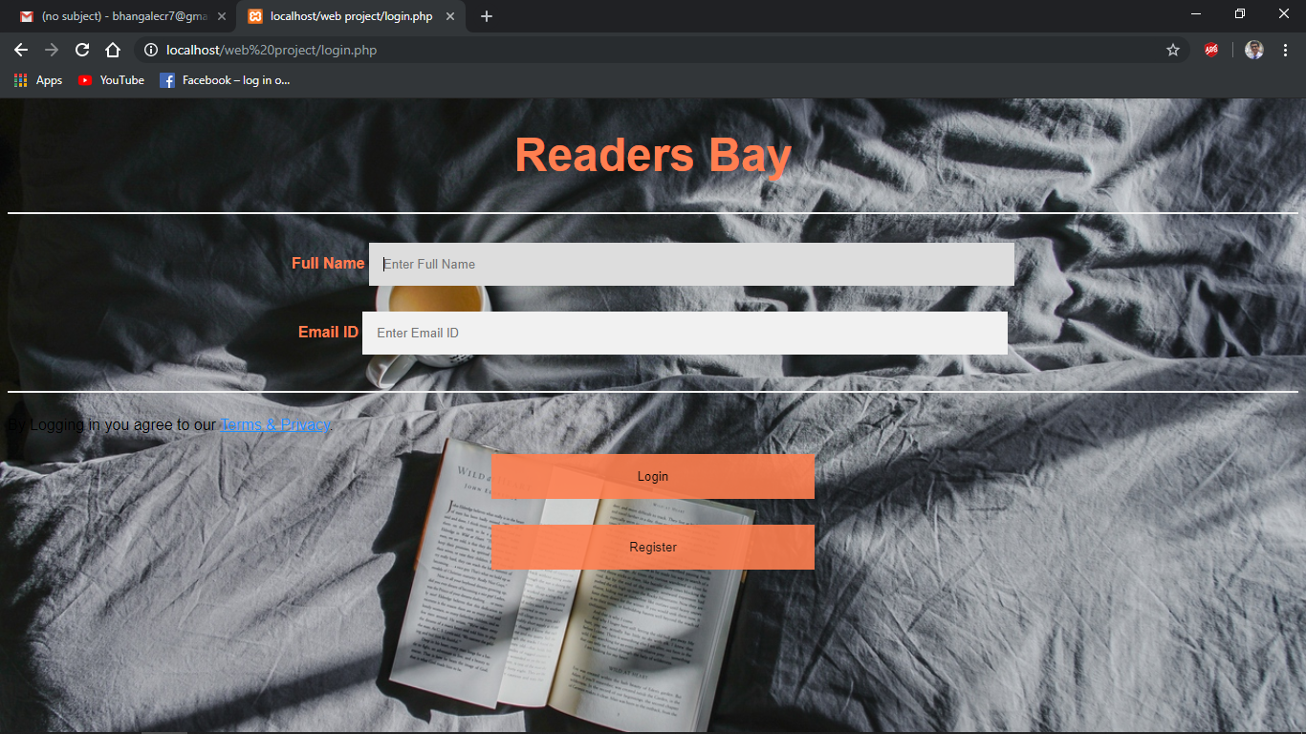

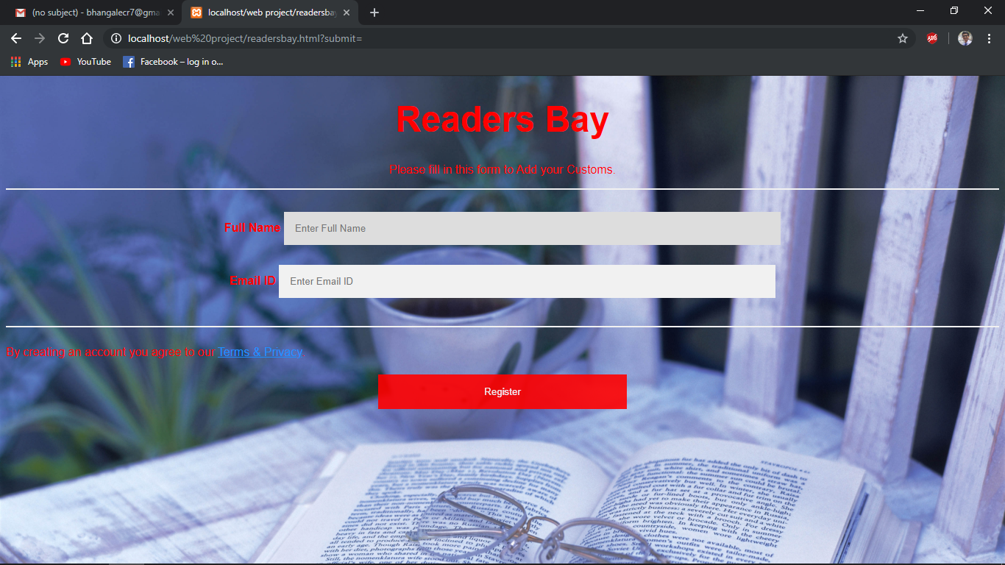

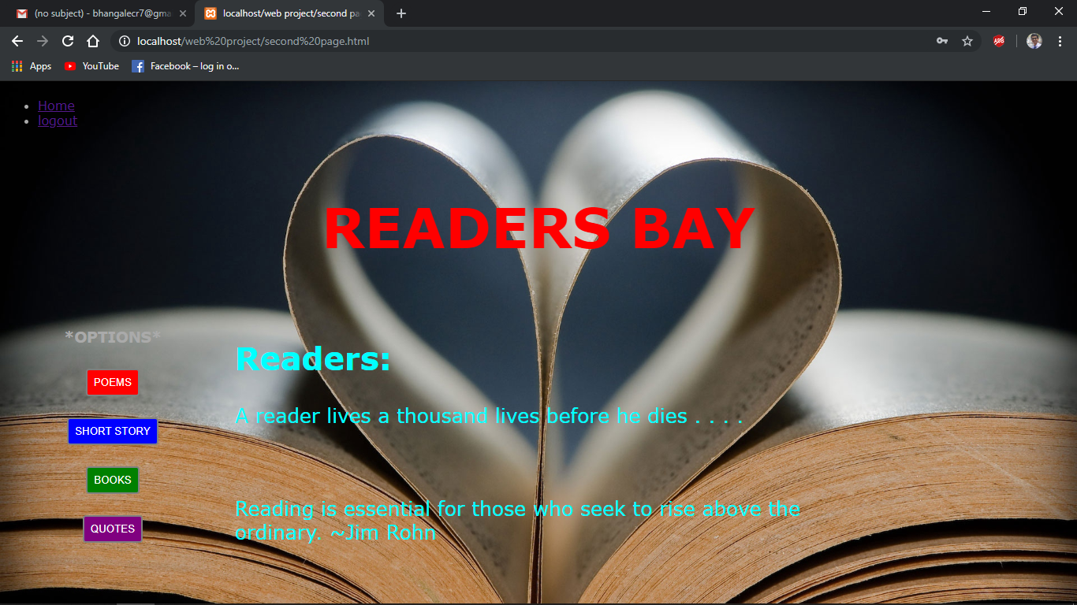

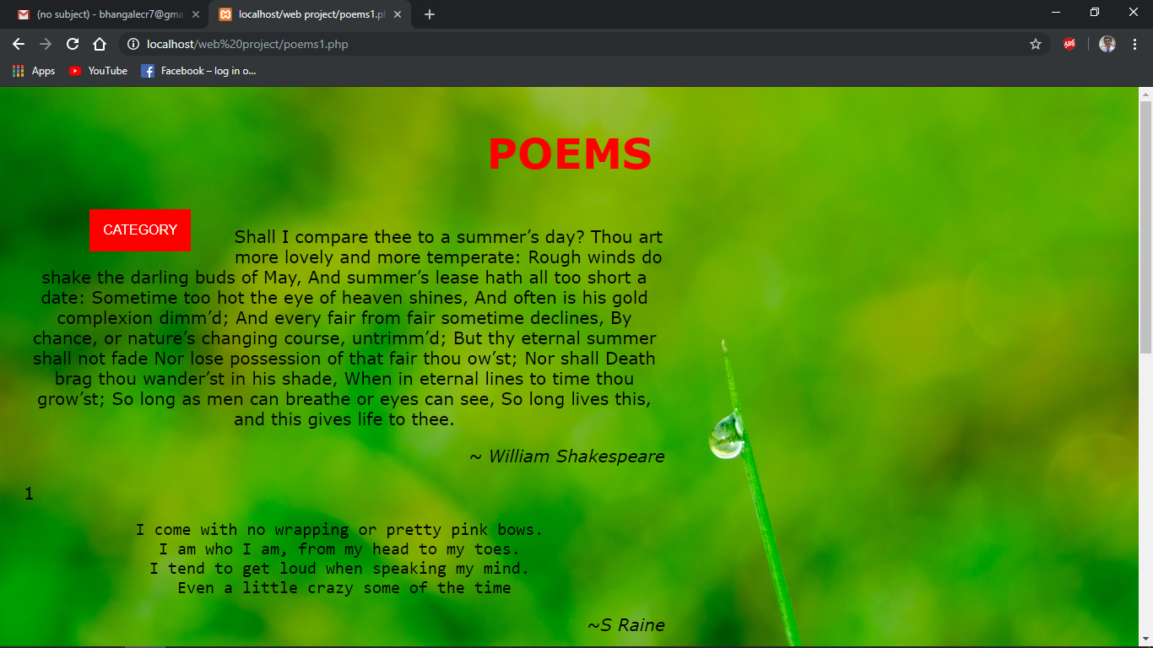

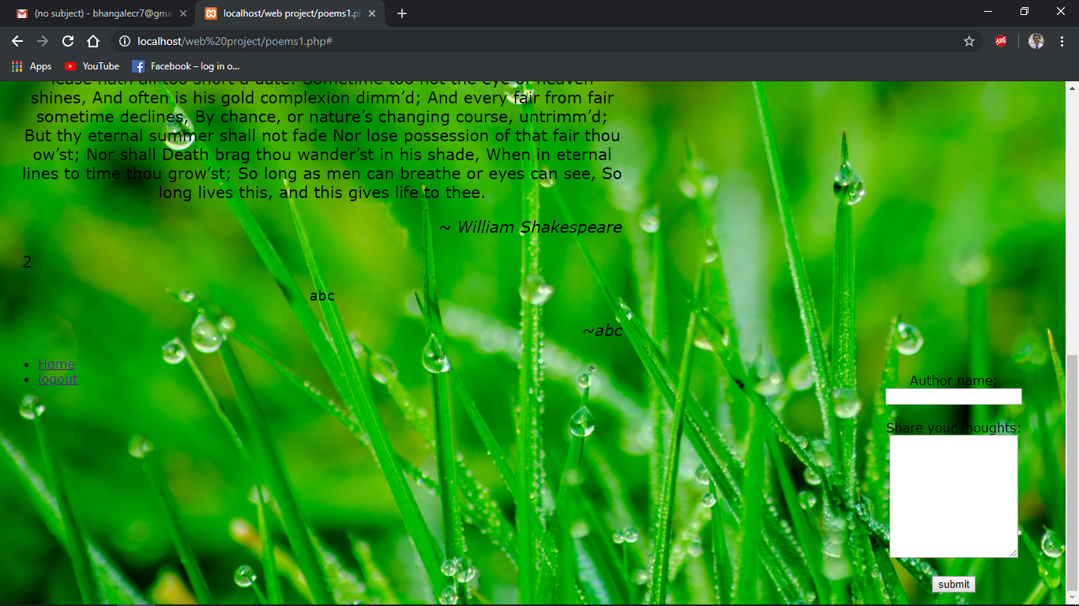

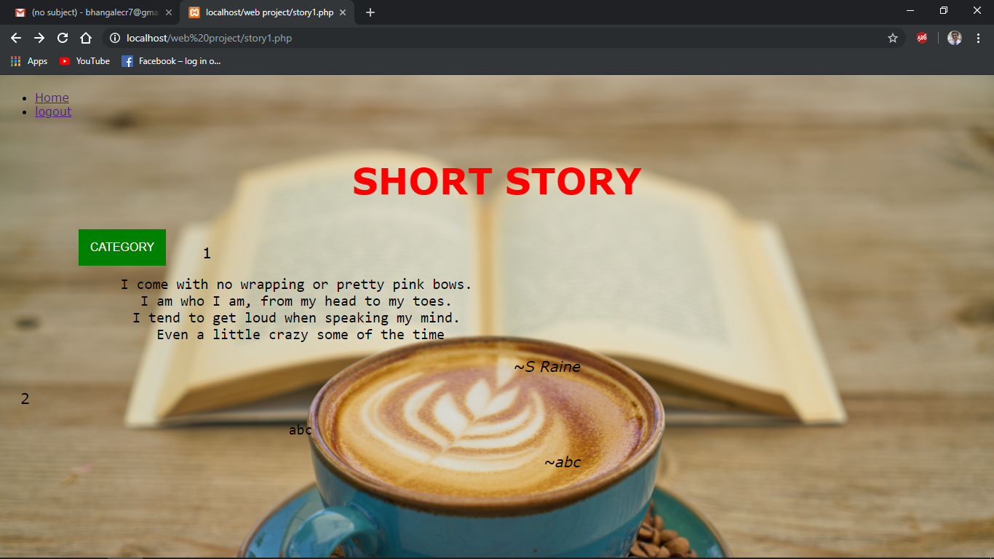

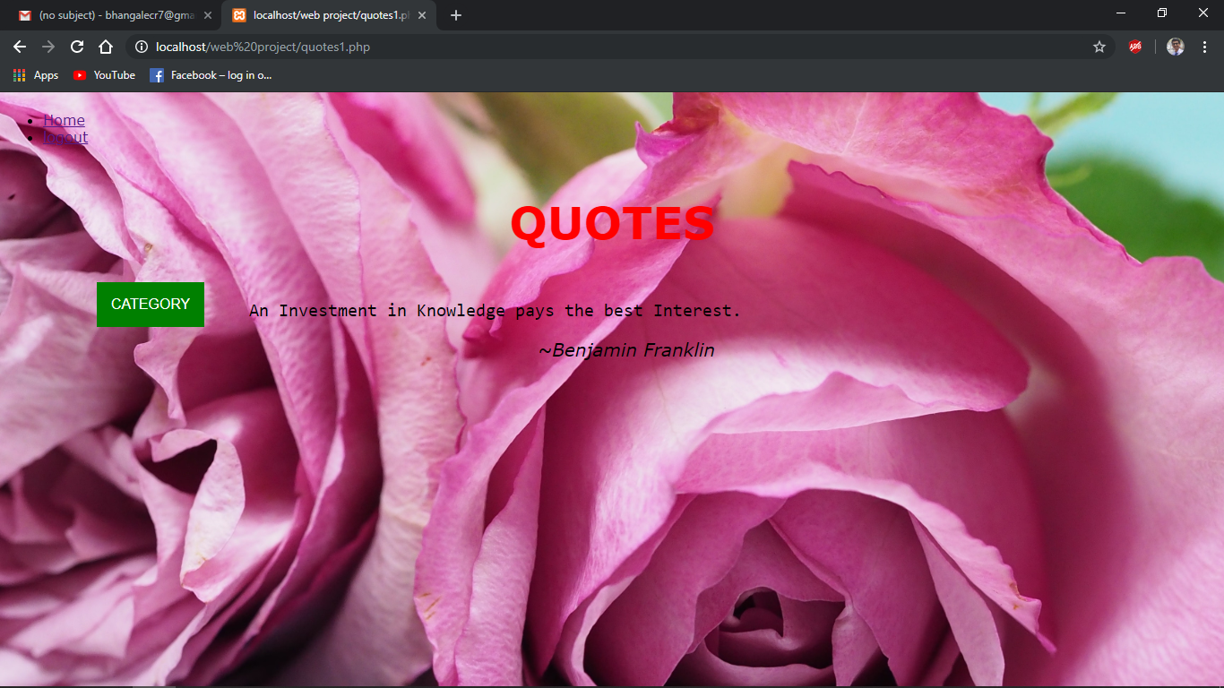

**CONCLUSION**

Through this project we are making online sources for reading books and other interesting write-ups to encourage the artistic mind of people. This website will help the readers to get these things on their fingertips anytime and anywhere they want. The writers who want to exhibit their talent of creative thinking by sharing the stories, express their emotions and feelings through the poems and, inspire and

motivate people with their thoughts and quotes are always welcomed to portray what they have.